**Data Engineering Assignment – 14**

**READ TEXT FILES INTO PYSPARK DATAFRAMES:**

* Using spark.read.text()

It is one way of loading the text files into pyspark dataframes.

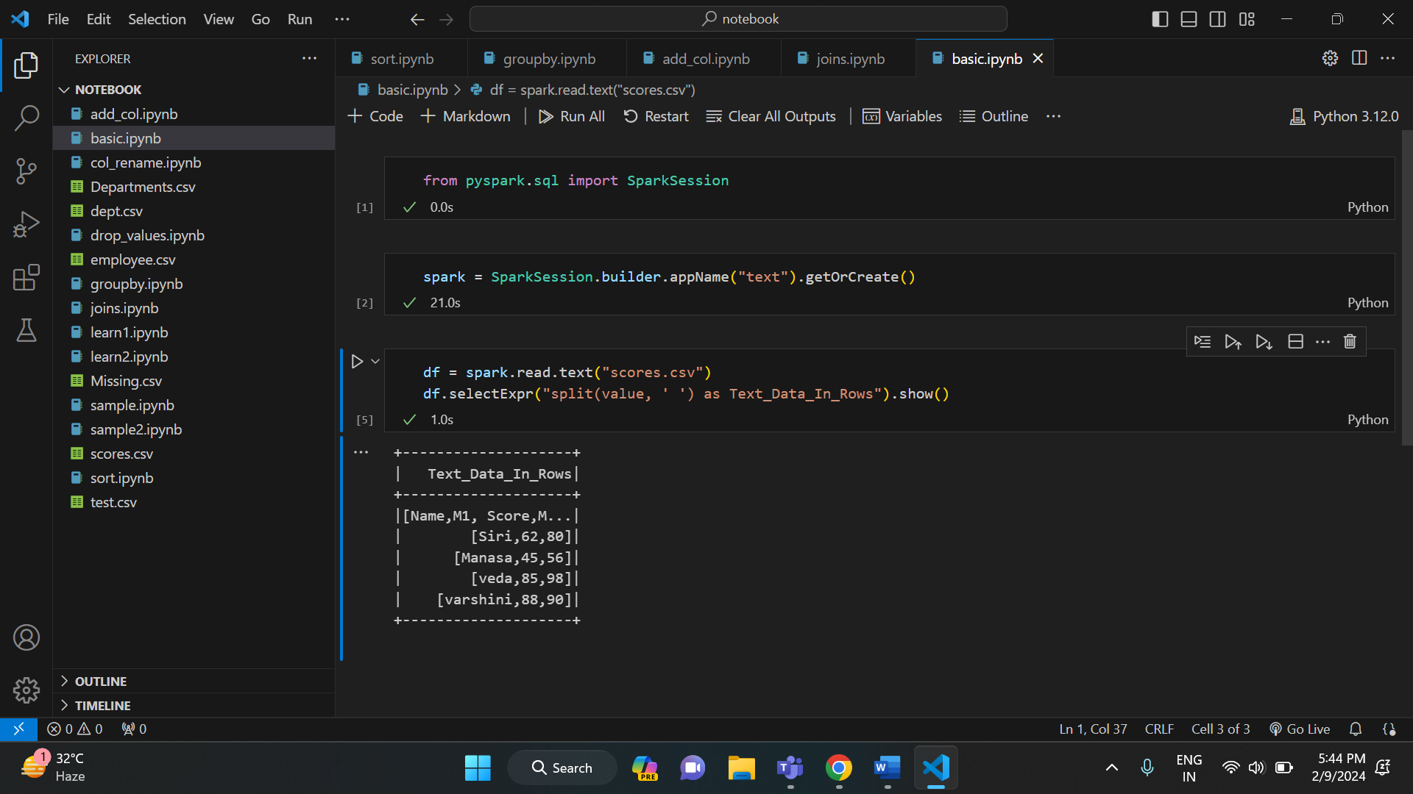

* Using spark.read.csv()

This is another method of loading data into pyspark dataframes.

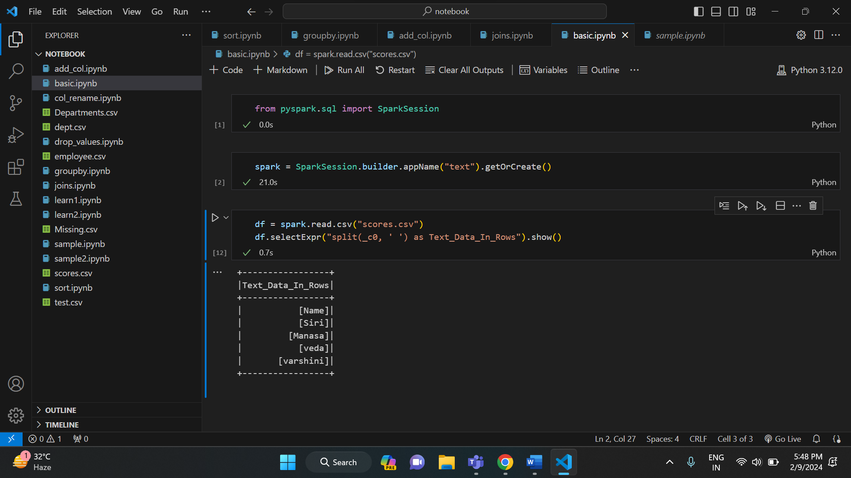

* Using spark.read.format(“text”).load()

It is used to load text files into DataFrame. The .format() specifies the input data source format as “text”.

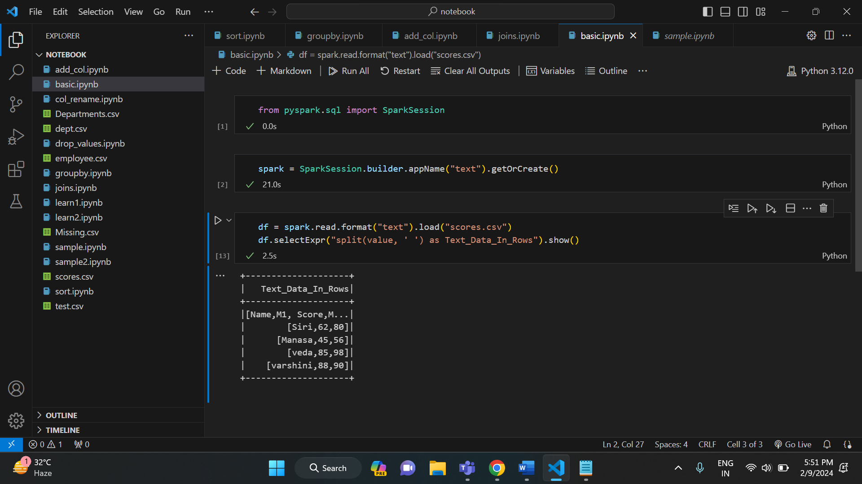

**ADDING NEW COLUMN TO PYSPARK DATAFRAME:**

* Add new column with constant value

In this approach to add a new column with constant values, the user needs to call the lit() function parameter of the withColumn() function and pass the required parameters into these functions.

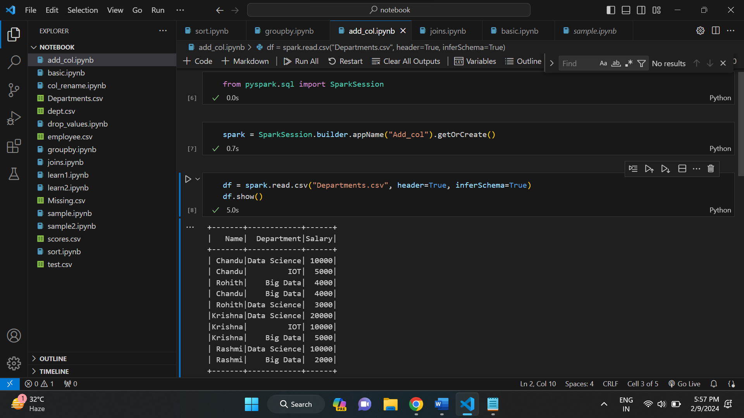

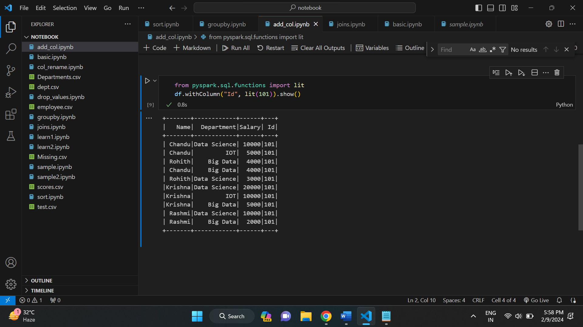

* Using concat_ws():

Here, the user has to concat the two existing columns and make them as a new column by importing this method from pyspark.sql.functions module.

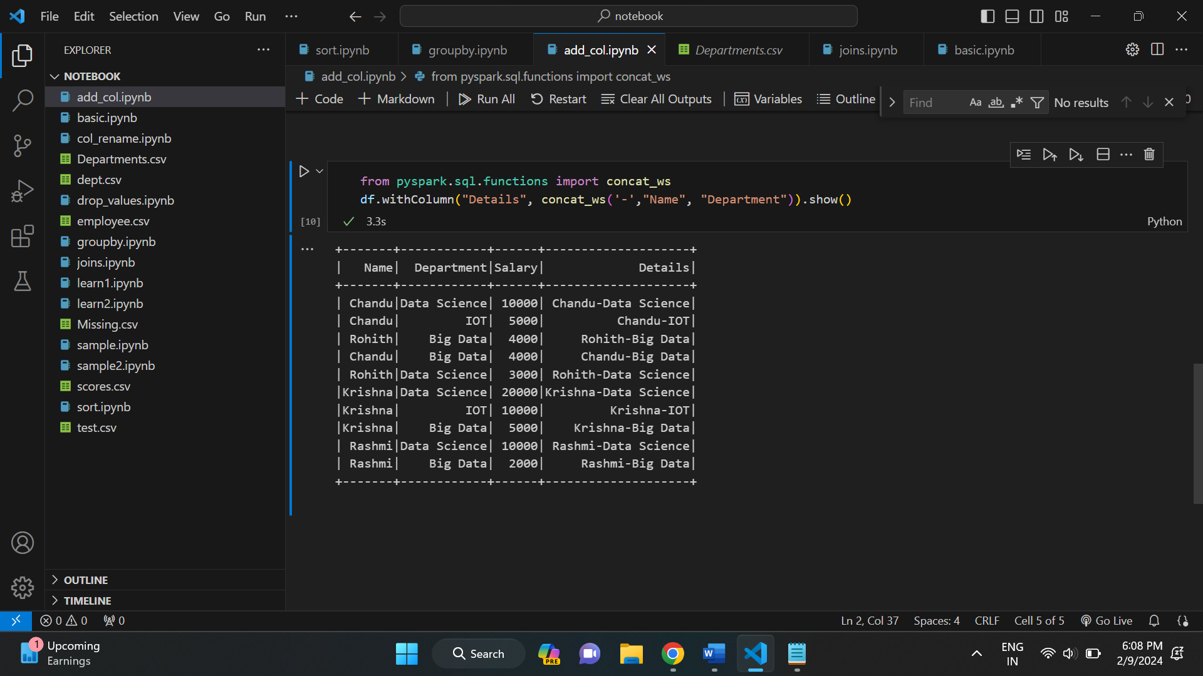

* Add column when not exists on dataframe

In this method, the user can add a column when it is not existed by adding a column with the lit() function and checking using if the condition.

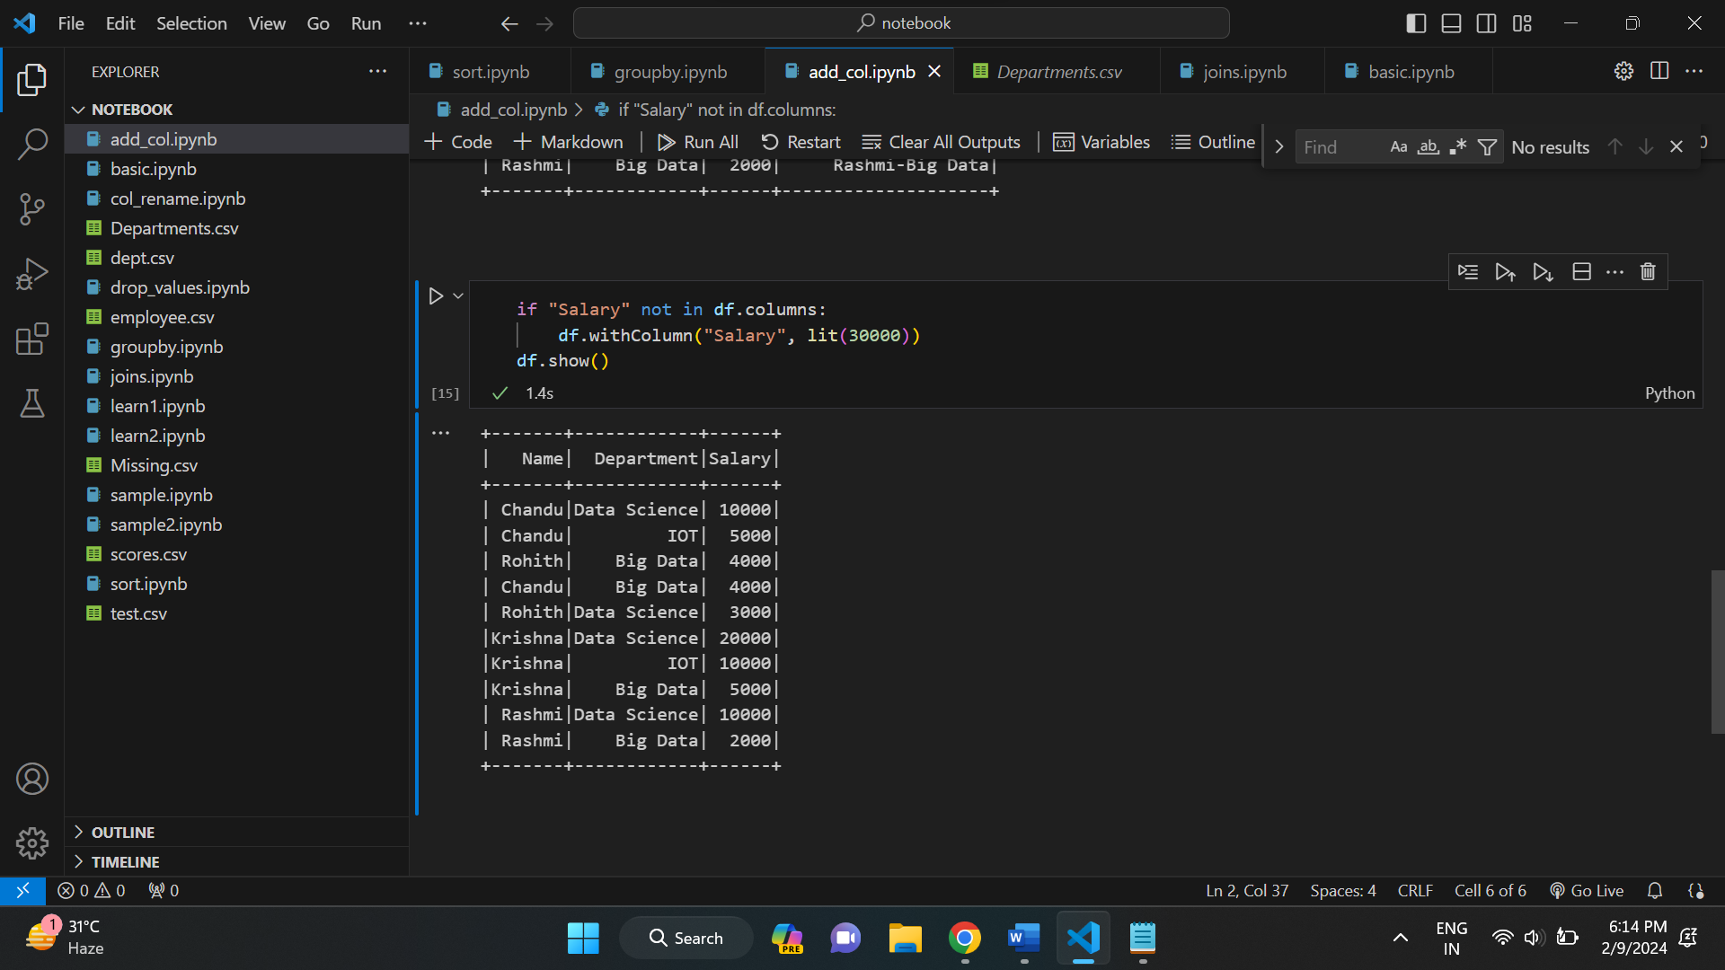

**Group By in pyspark:**

Similar to SQL GROUP BY clause, PySpark groupBy() function is used to collect the identical data into groups on Dataframe and perform count, sum, avg, min, and max functions on the grouped data.

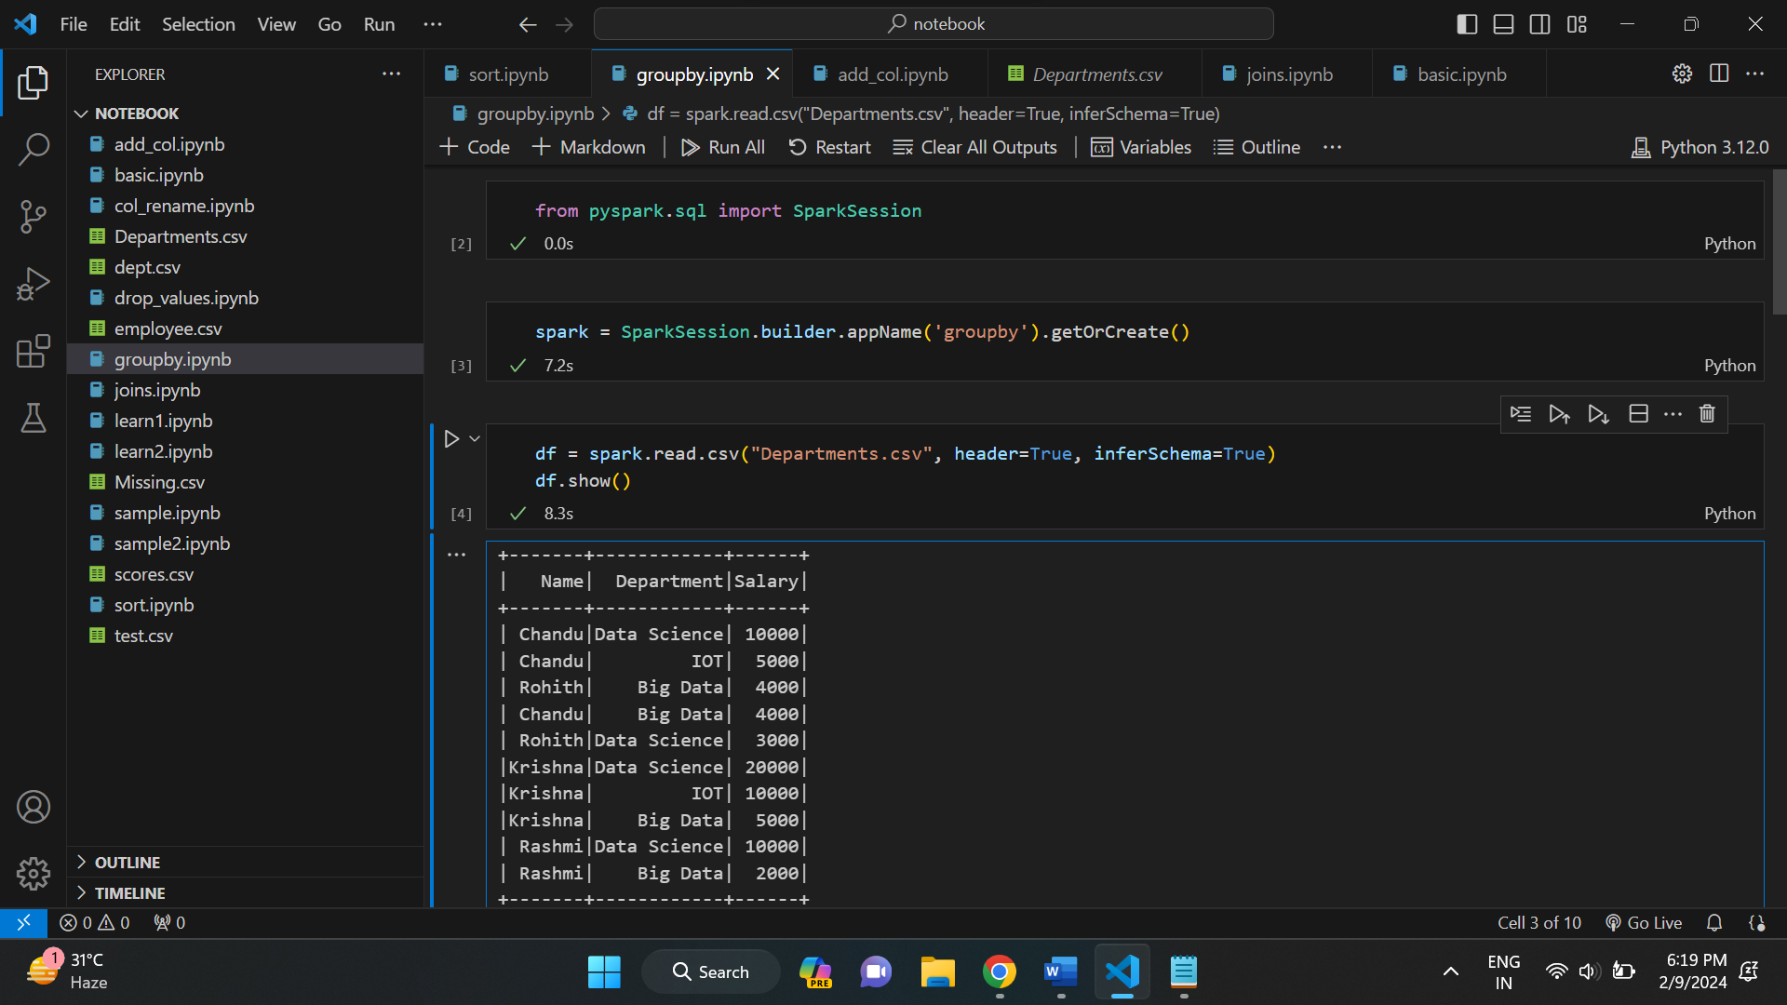

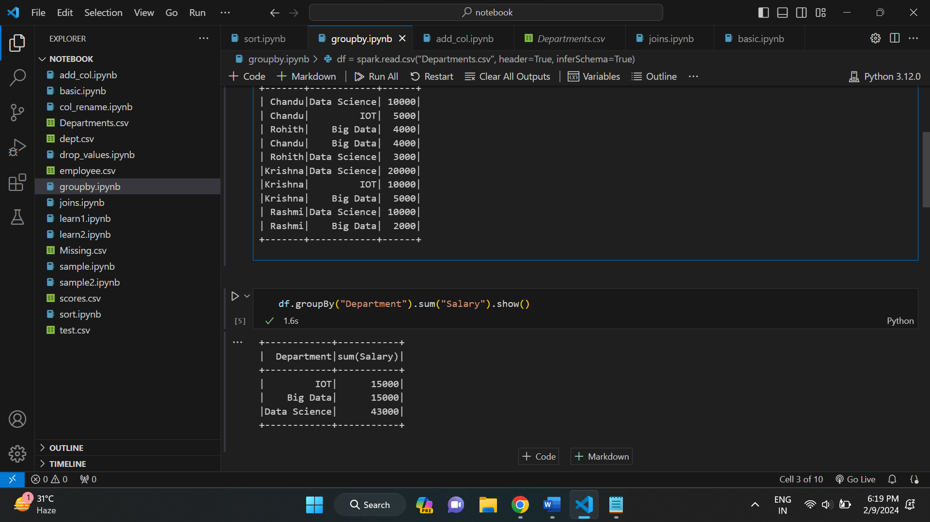

Here, we are grouping sum of salary data based on department.

**AGGREGATE FUNCTIONS IN PYSPARK:**

Similar to SQL, we also have aggregate functions in pyspark. We have sum(), max(), min(), count(), avg() etc.

Examples:

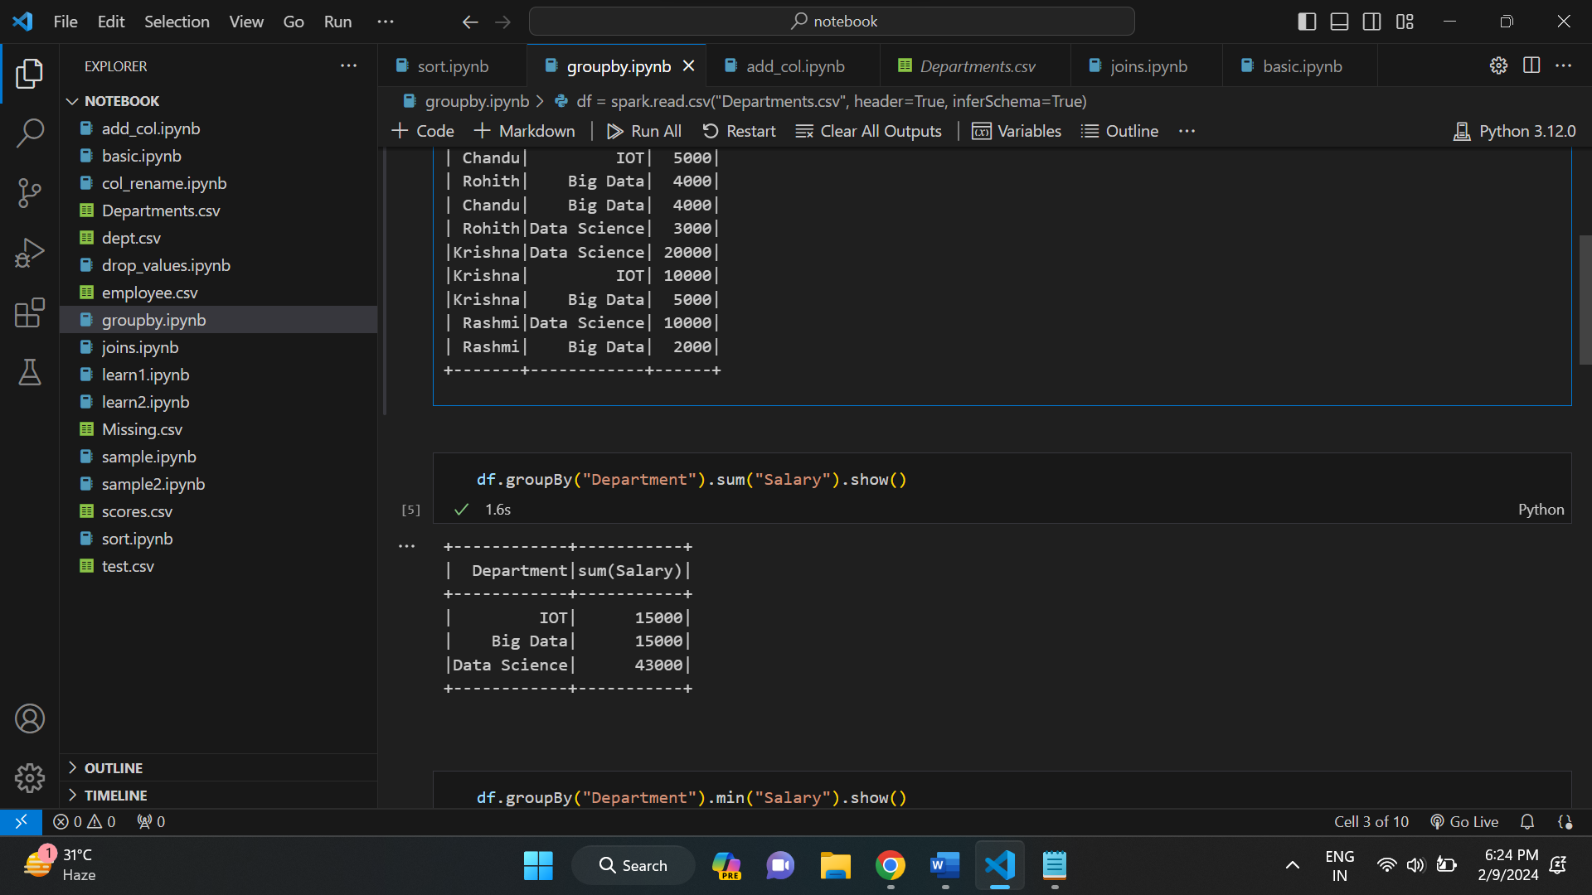

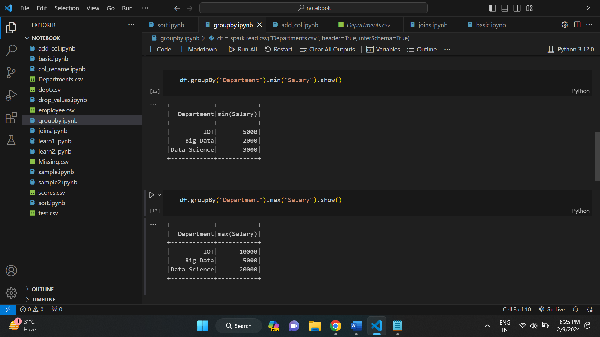

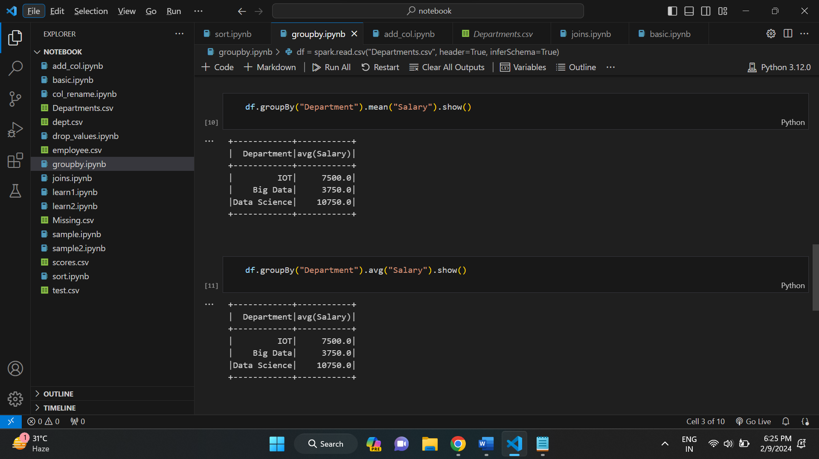

**HANDLING MISSING VALUES IN PYSPARK:**

* Dropping rows having null values:

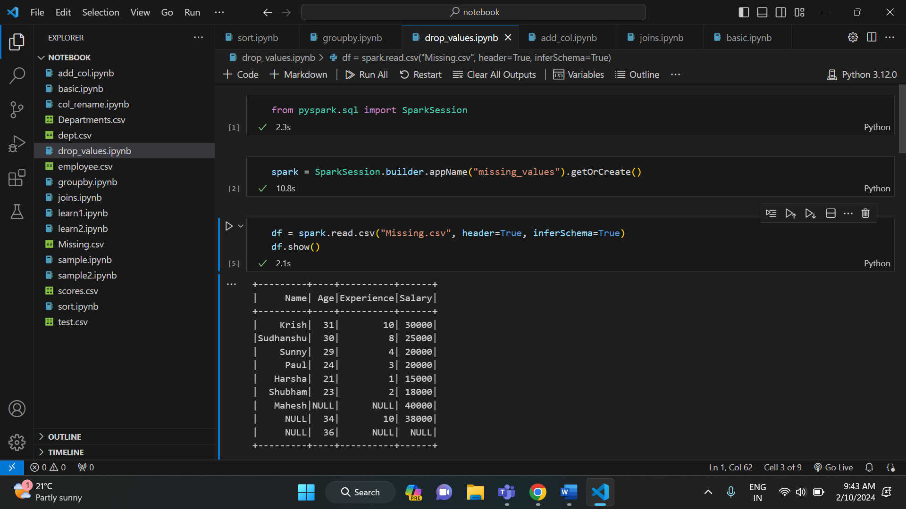

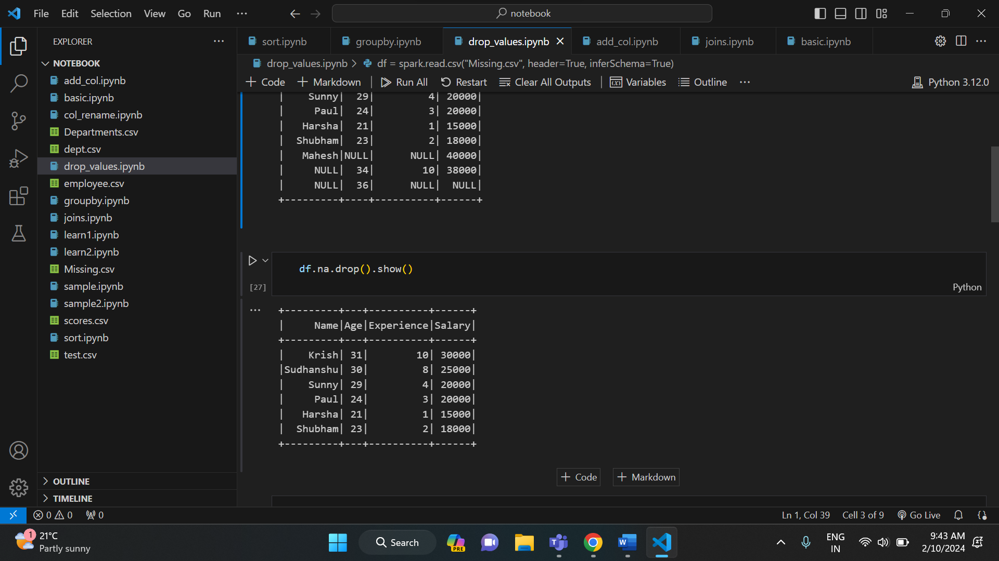

* Using na.drop() with other parameters:

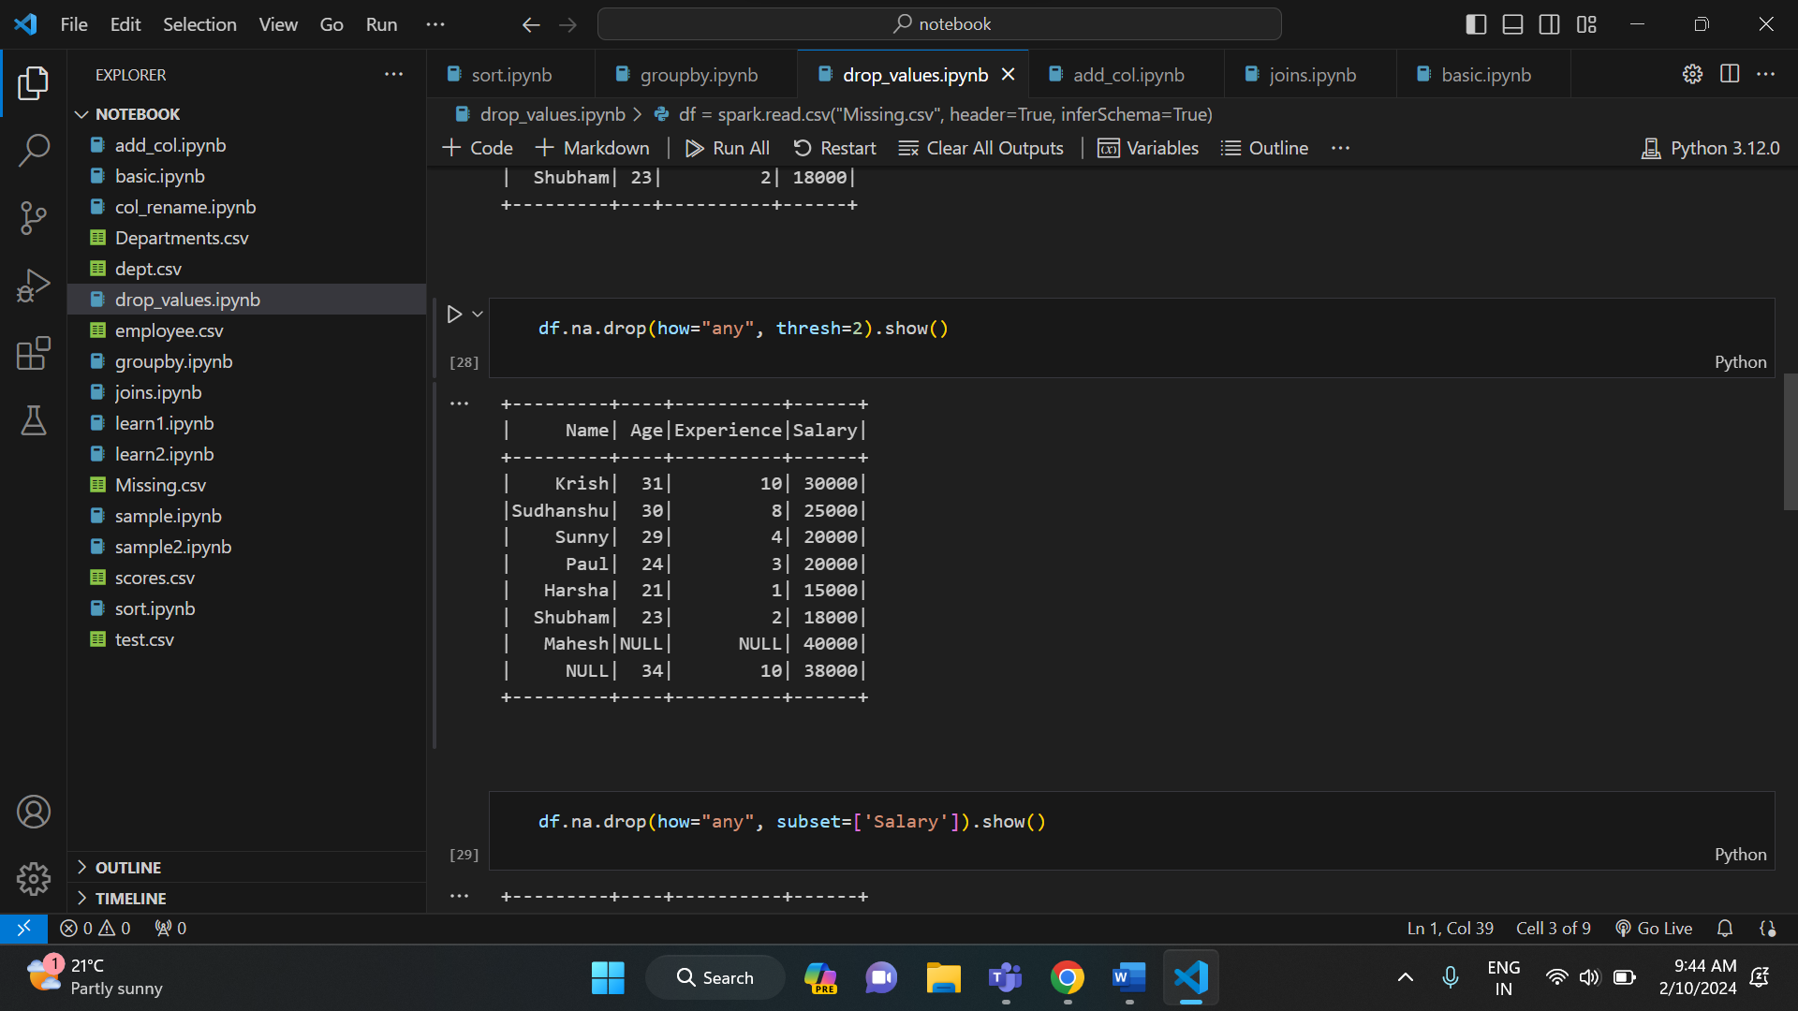

**FILLING MISSING VALUES:**

* Filling null values

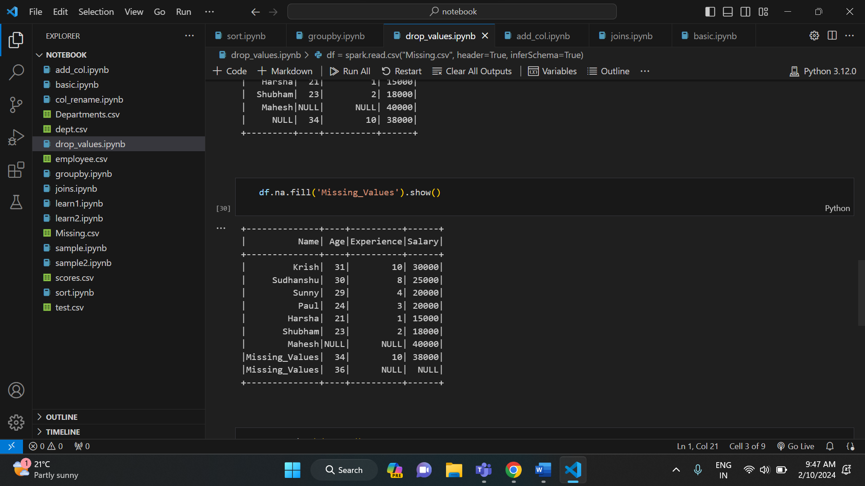

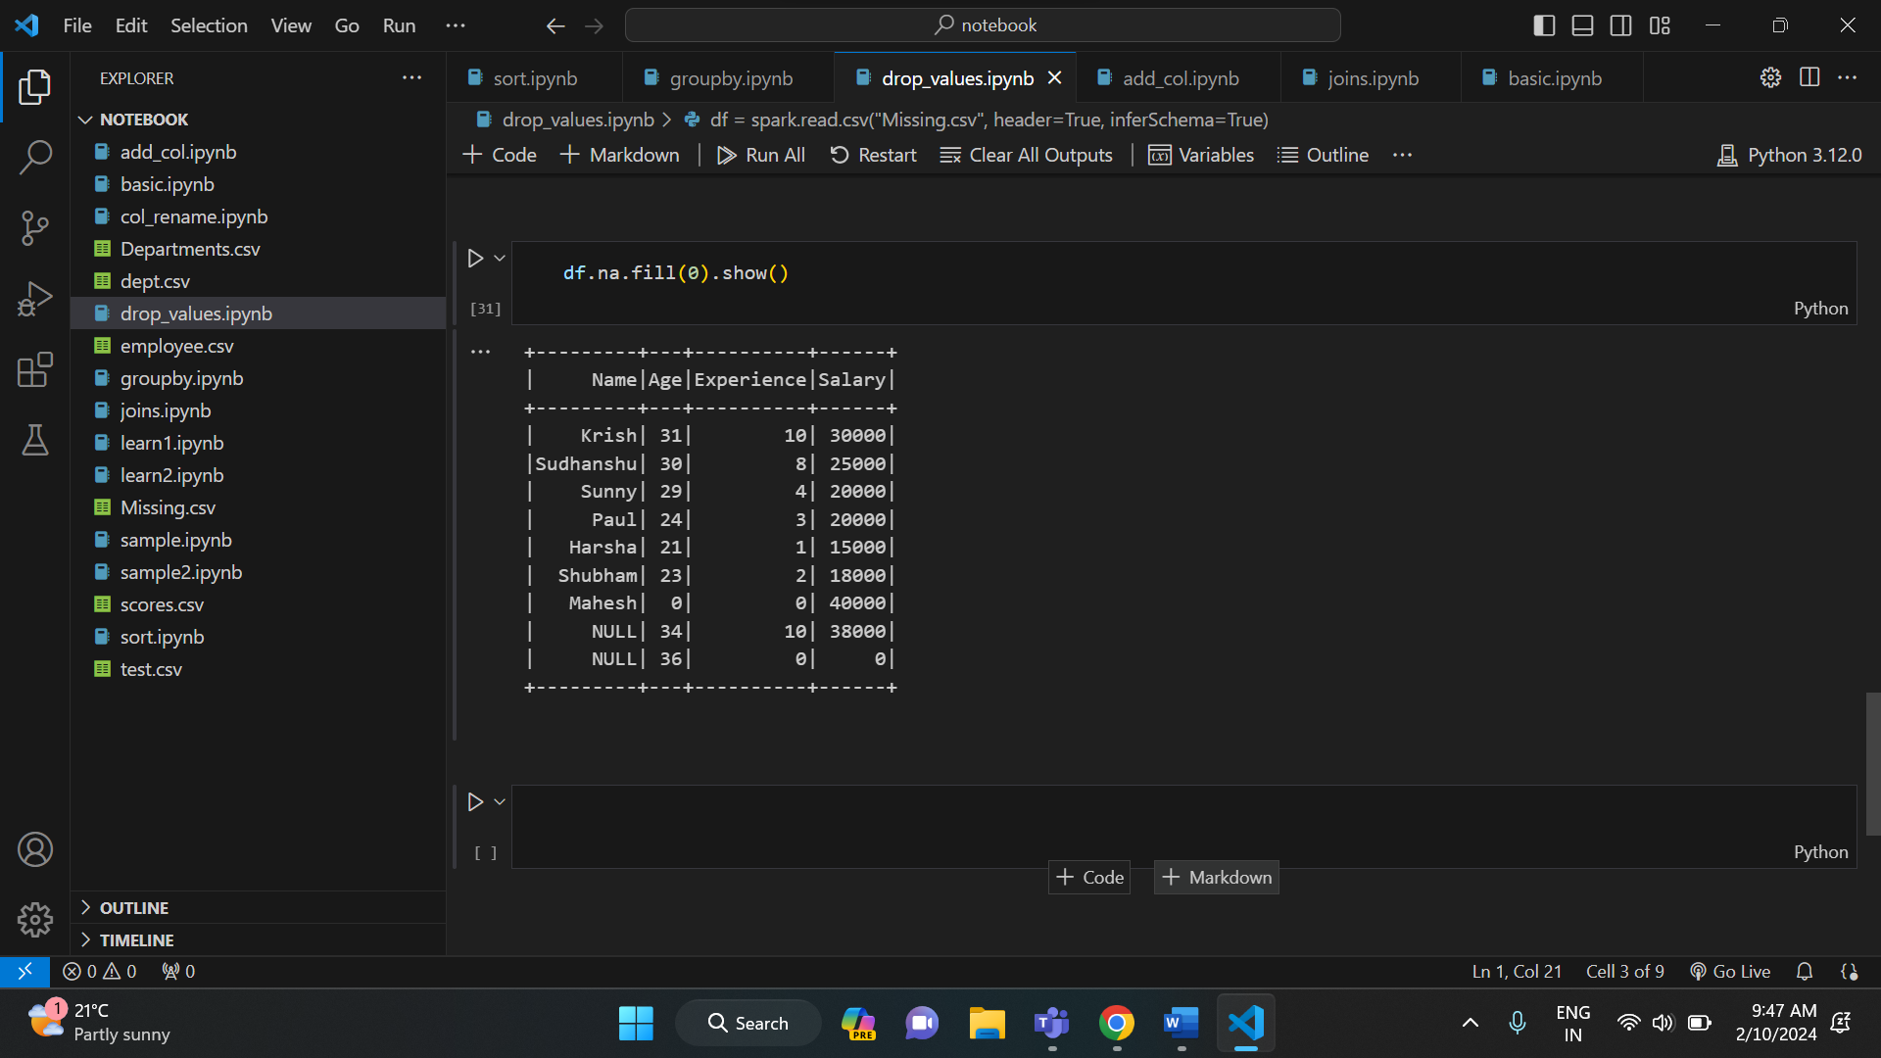

**Order by() and sort() in pyspark:**

* Sort ():

To sort a dataframe by using one or more columns, default ascending order.

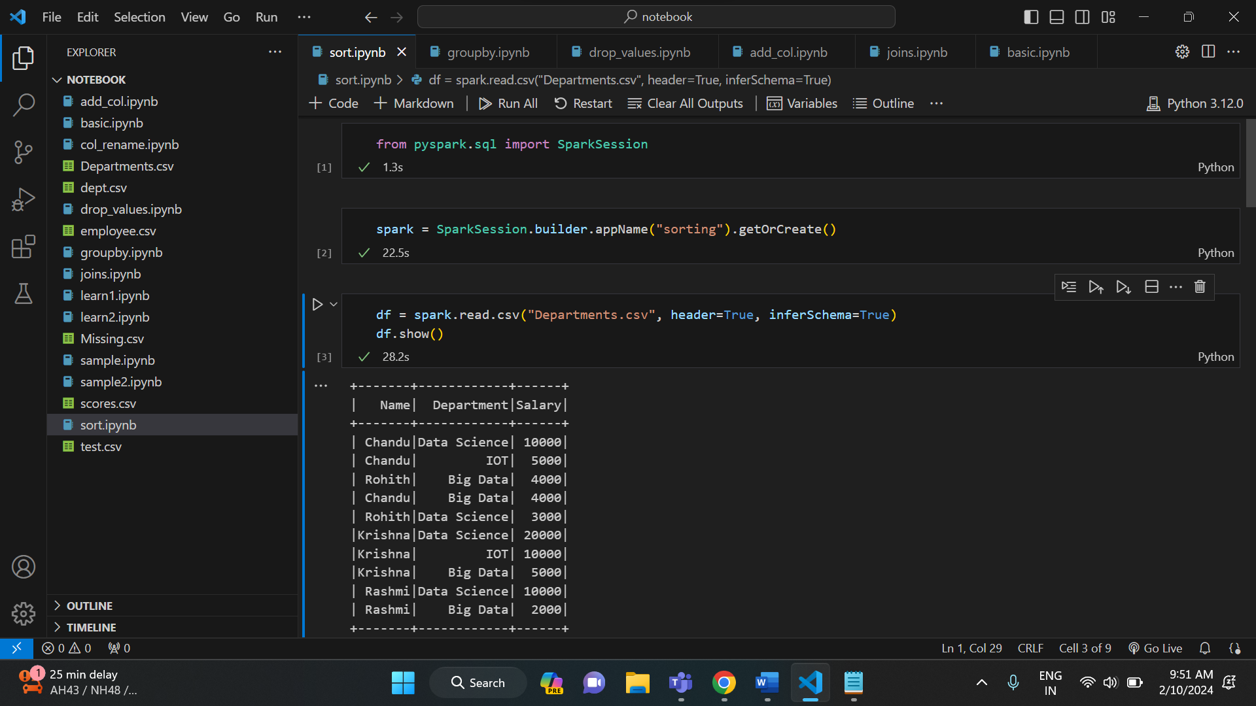

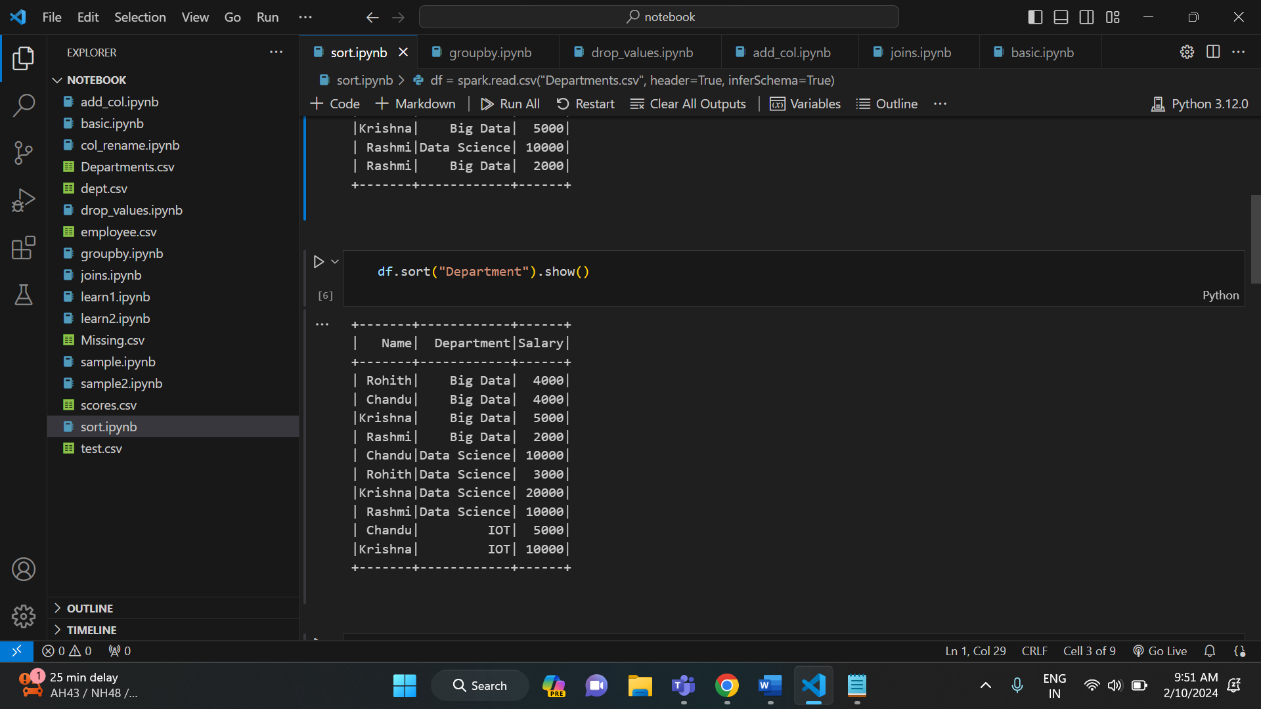

* Sorting in descending order

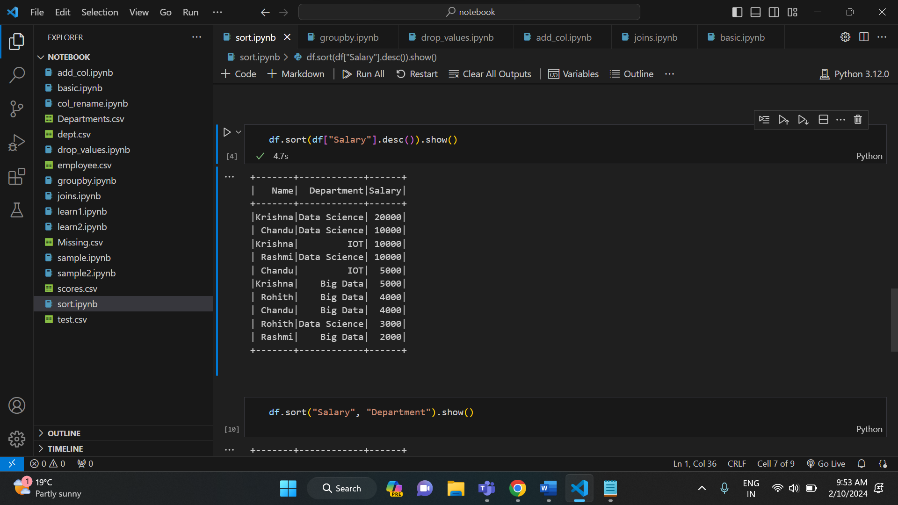

* Sorting based on two columns

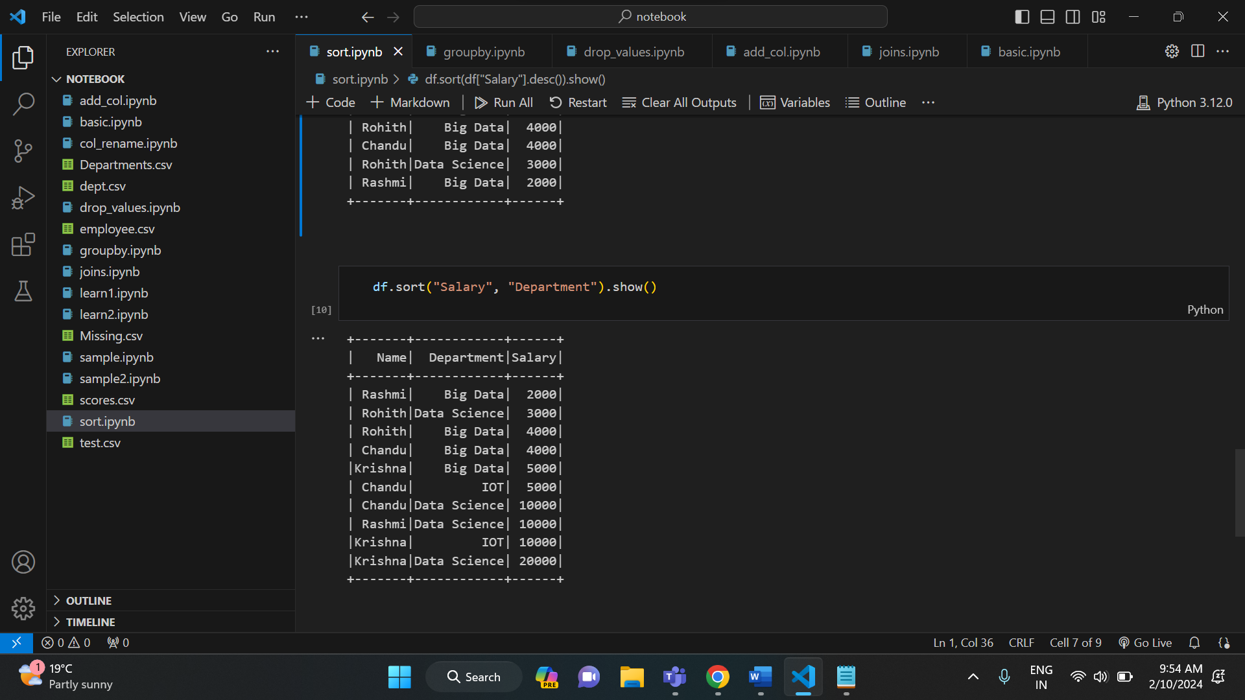

Orderby ():

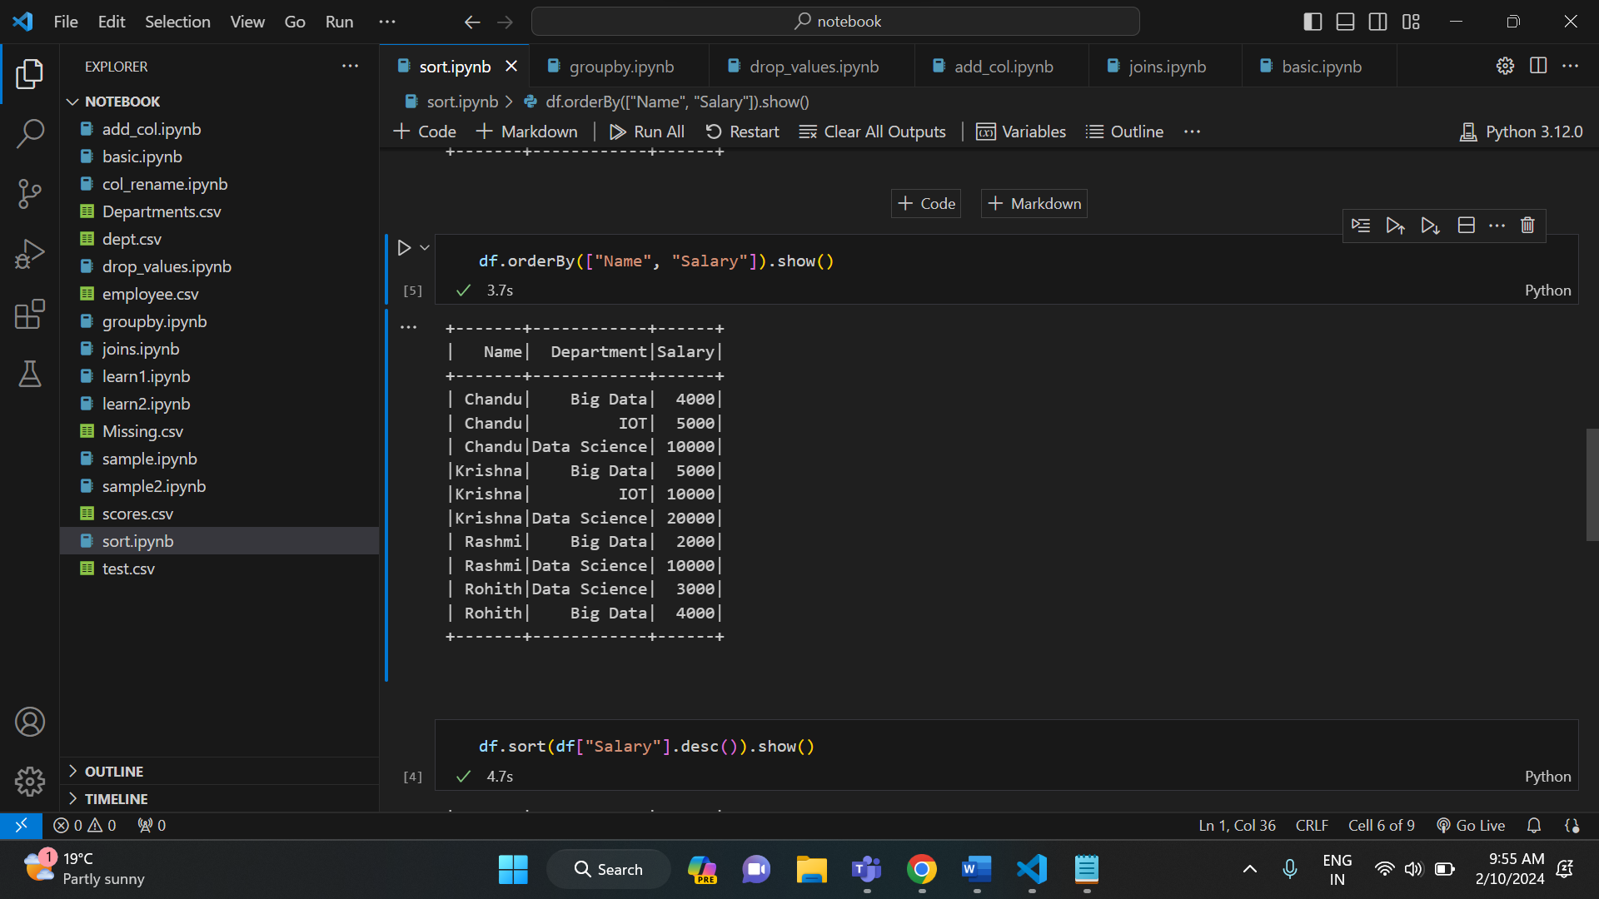

**JOINS IN PYSPARK:**

Similar to SQL, there are different types of joins in pyspark. They are:

* Inner join:

It joins records when key columns are matched and drops when they are not matched.

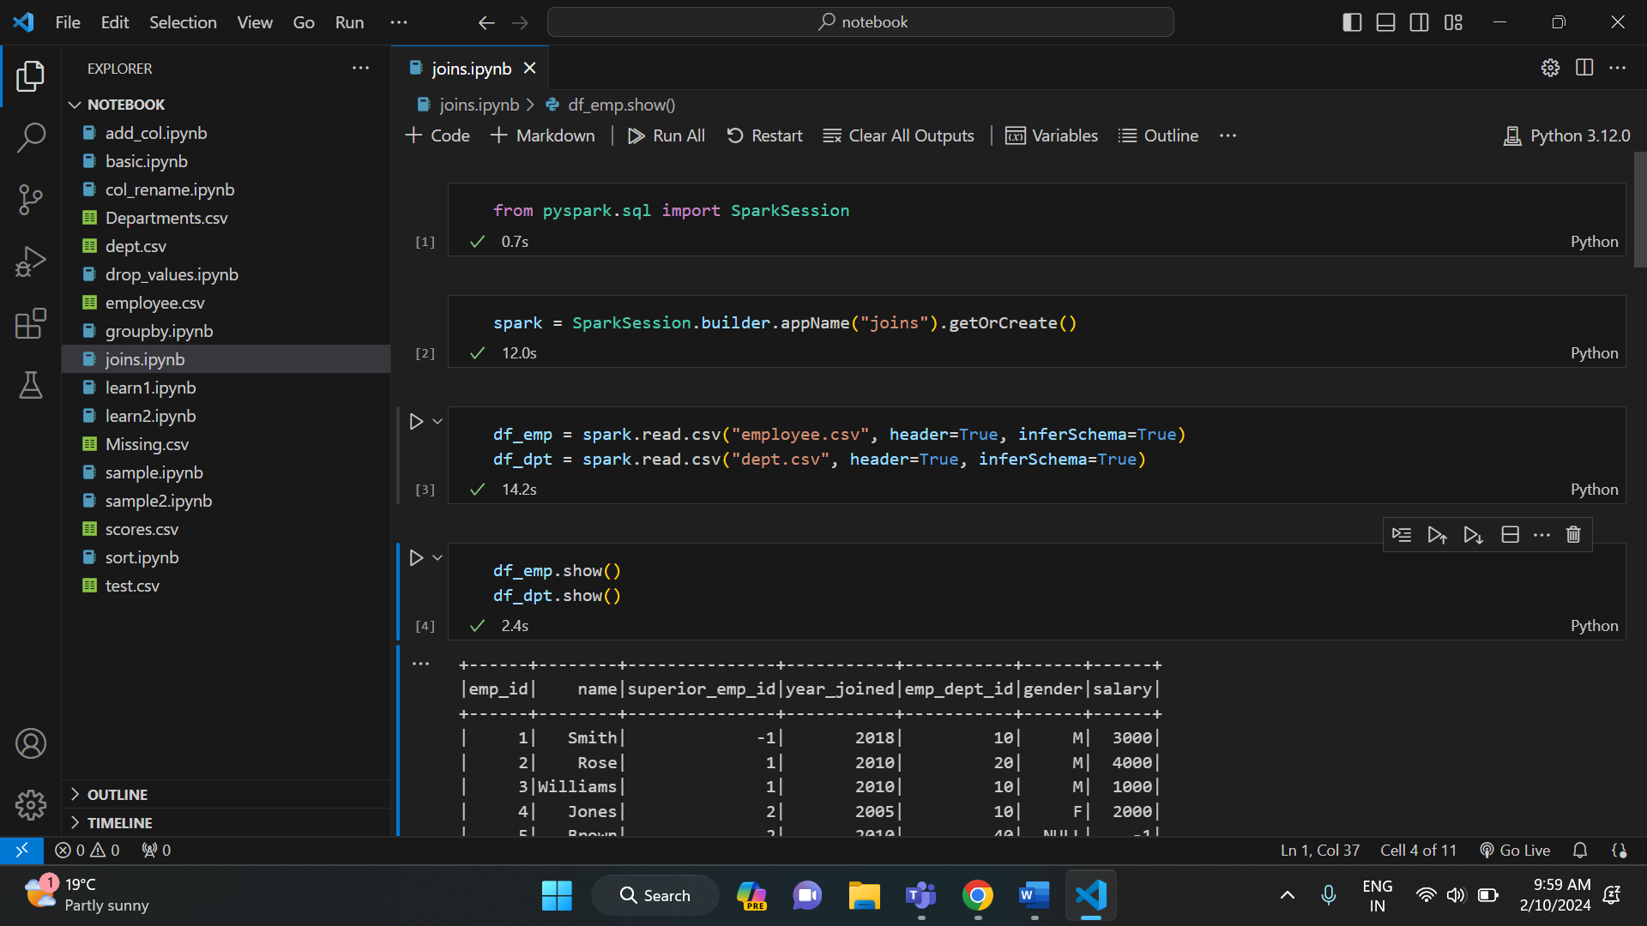

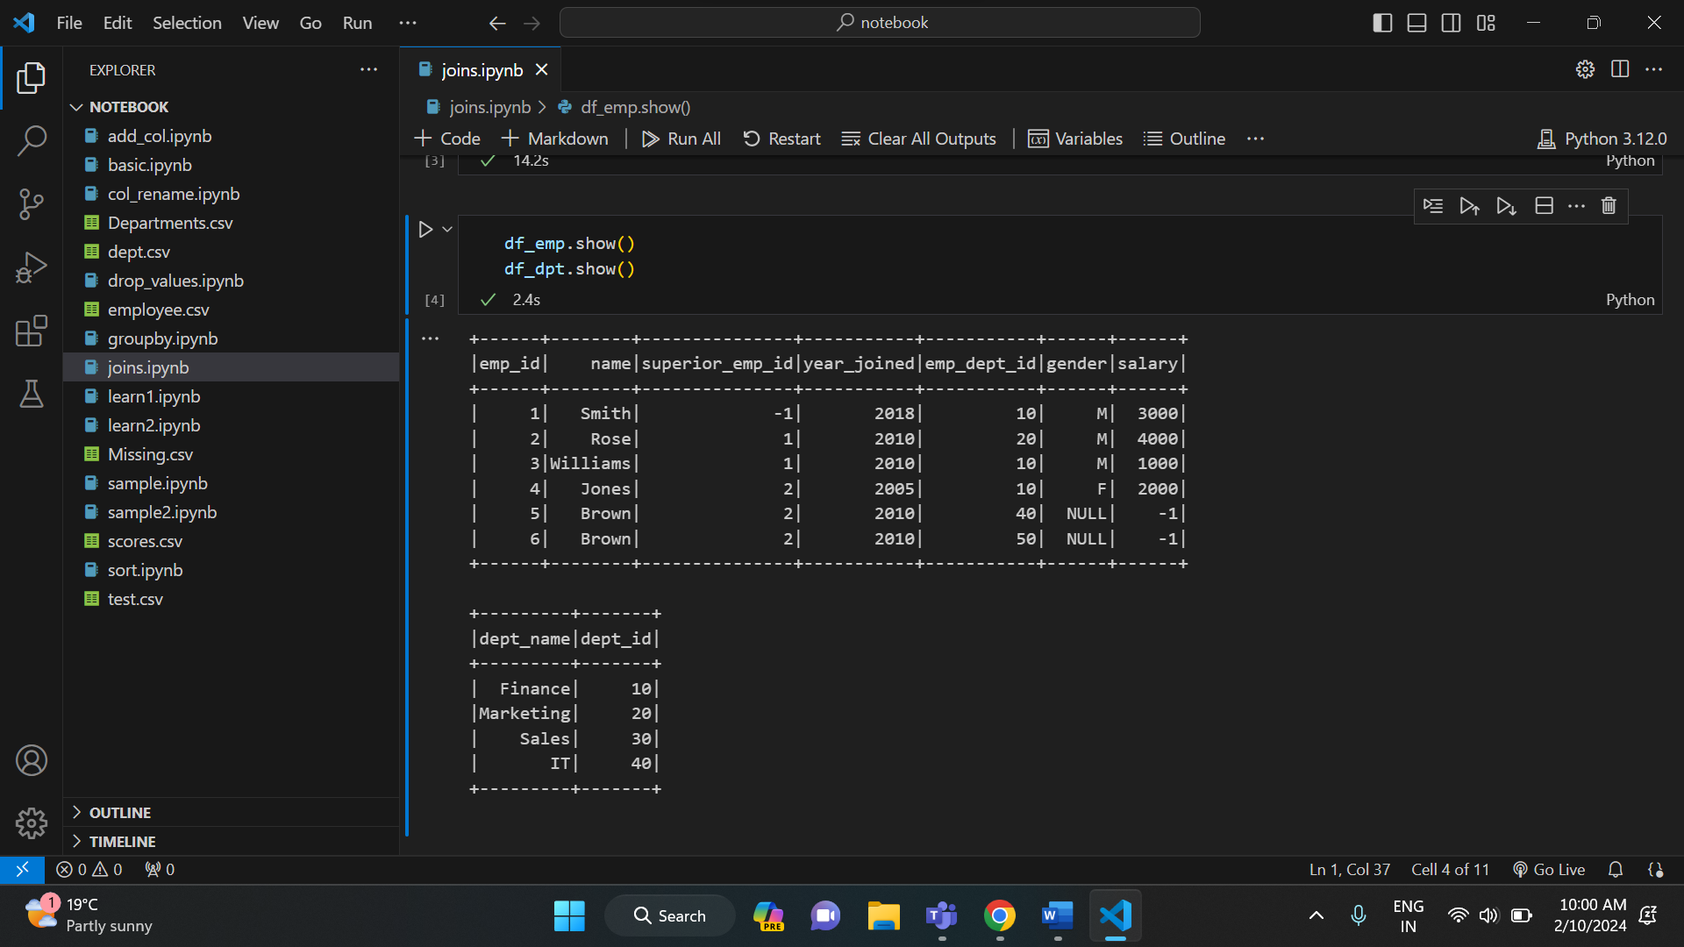

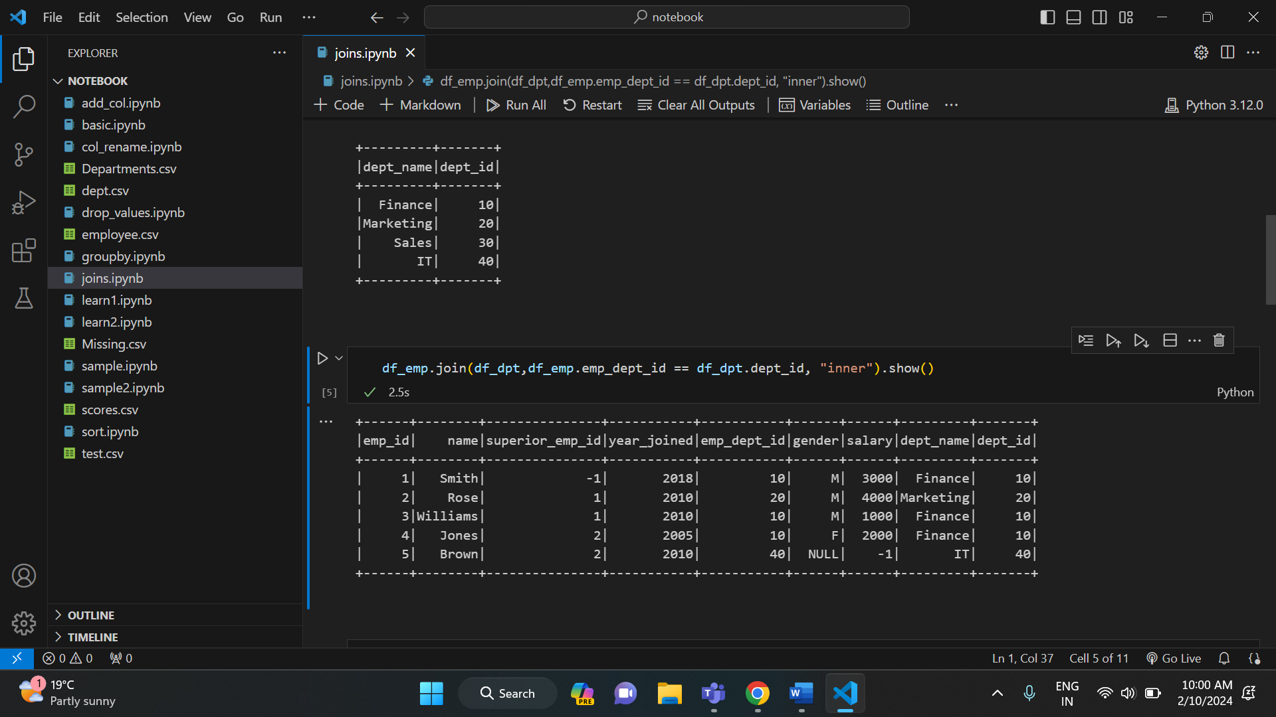

* Outer join:

It returns all rows from both datasets, where join expression doesn’t match it returns null or respective columns.

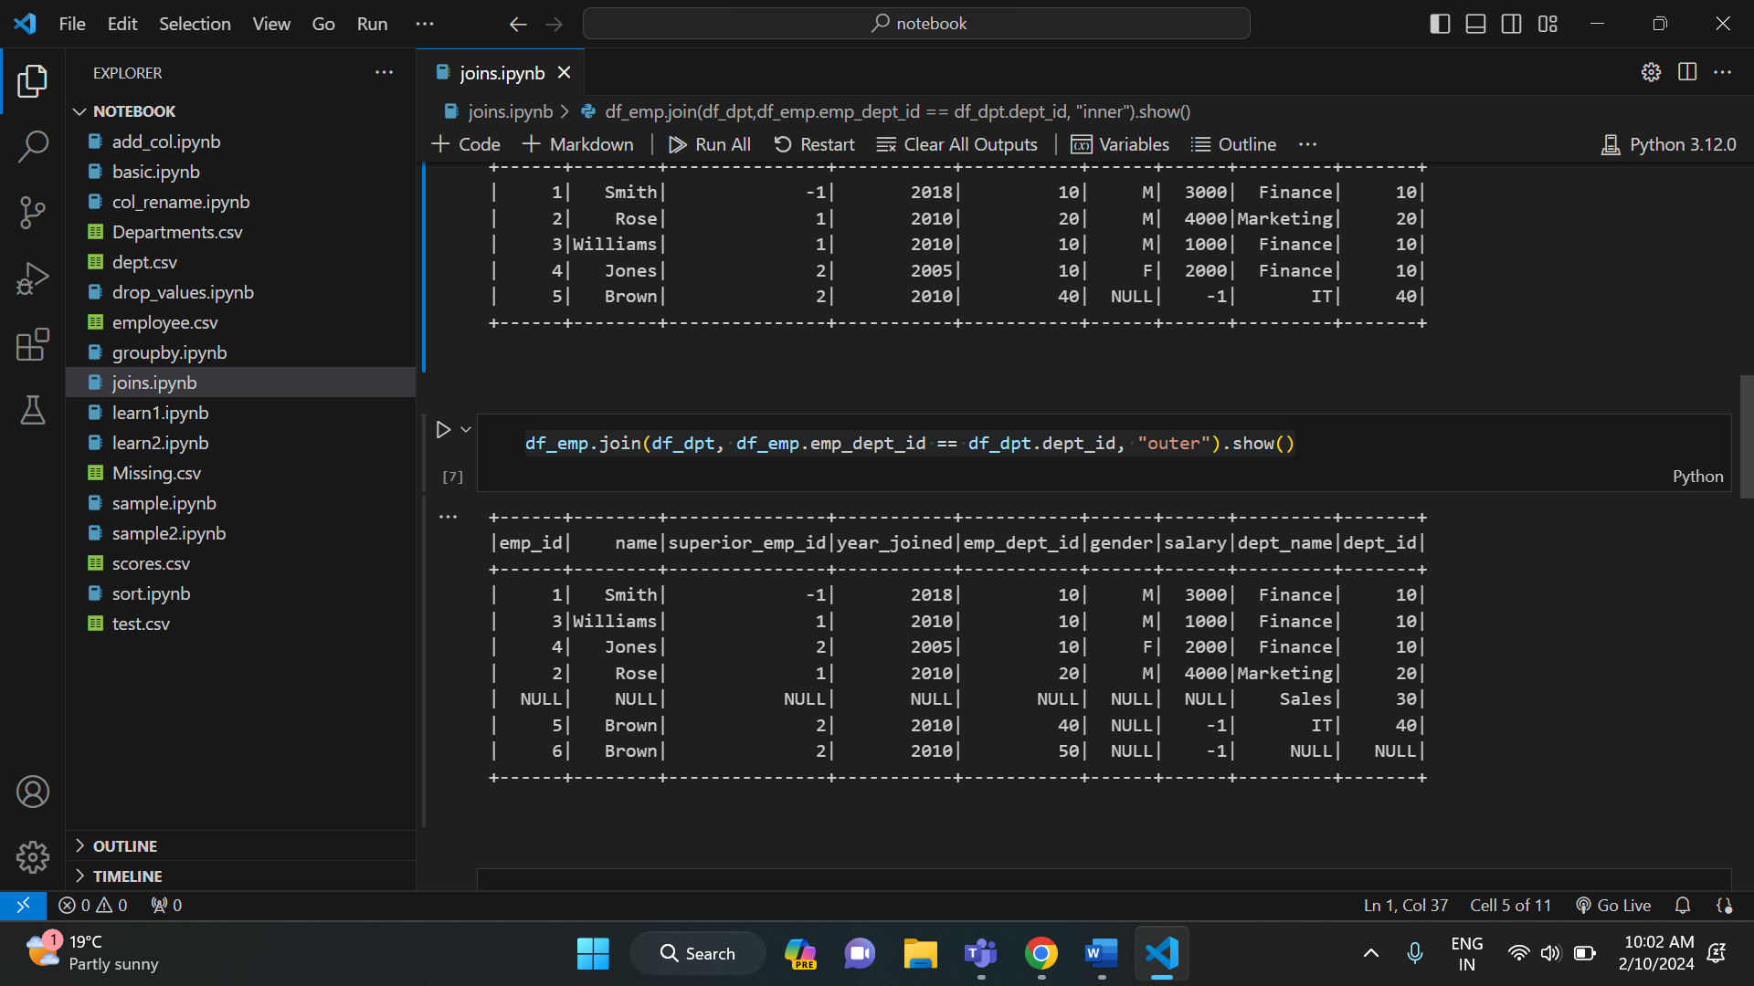

* Left join:

It returns all rows from left dataset irrespective of match found on right dataset, when join doesn’t matches it assigns null for that record.

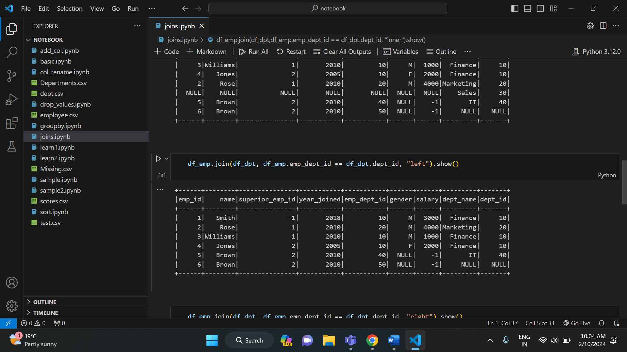

* Right join:

It returns all rows from right dataset regardless of match found on left dataset. When join doesn’t match it assigns null for that record.

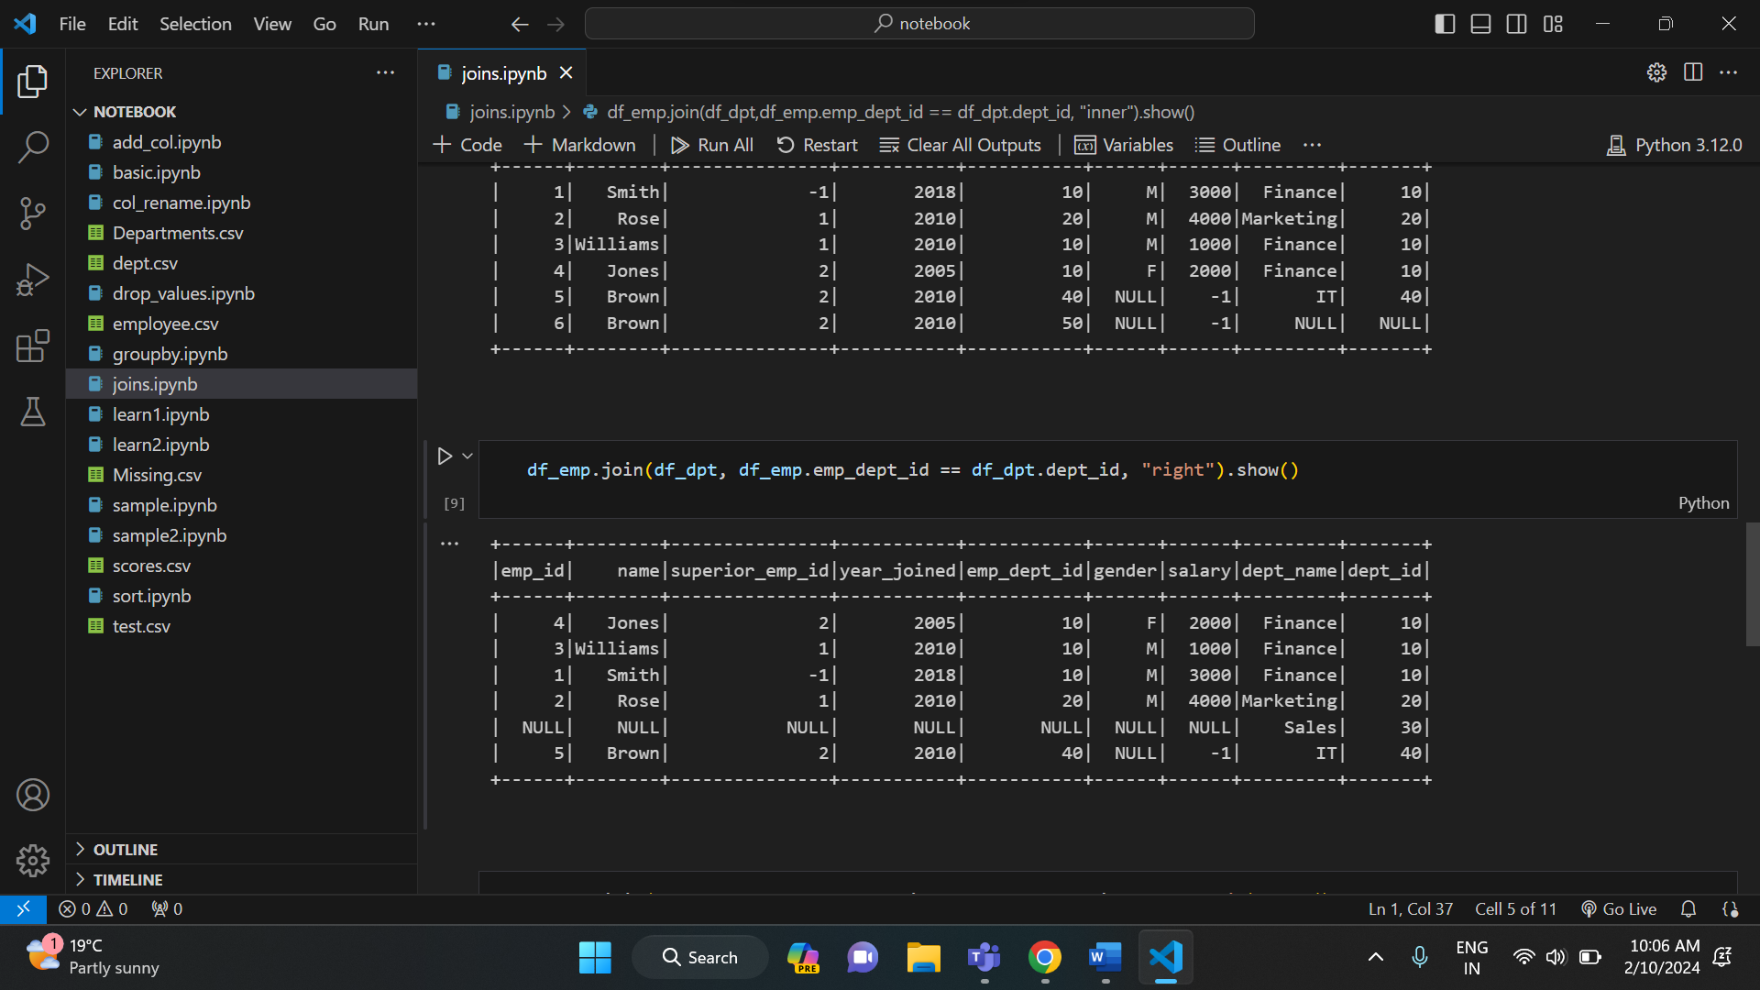

* Left semi join:

It returns columns from only left dataset for the matched records in the right dataset on join expression.

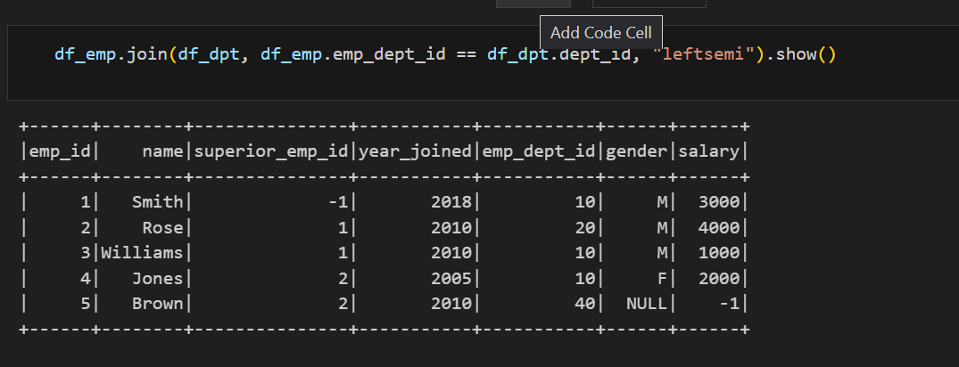

* Left anti join:

It returns columns from left dataset for non-matched records.

